Assignment Instructions
You are to complete 1 assignments before moving onto your project. Your assignment will be work 25 points.
Choose 1 assignment from the following list. The labs that you chose will help prepare you to execute an idea that would be applicable to the following image-development strategies.
Image Development Strategy/Theme | Examples
1. Distortion | 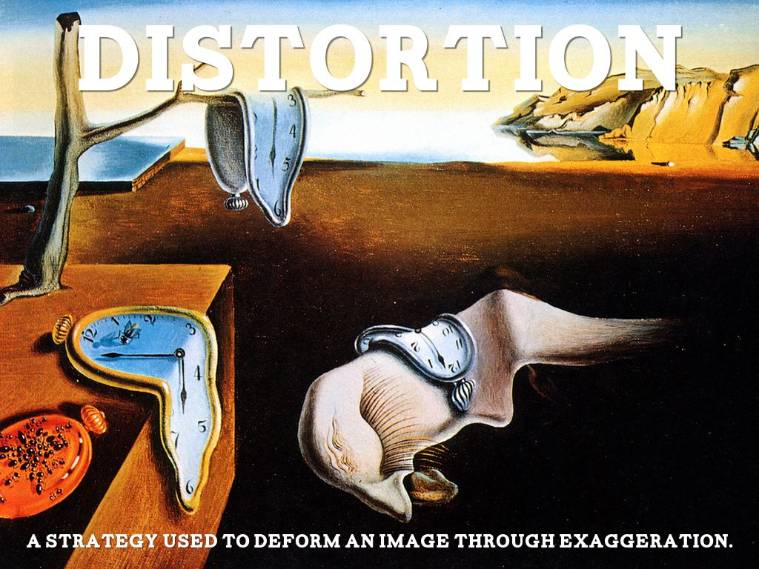
2. Exaggeration | 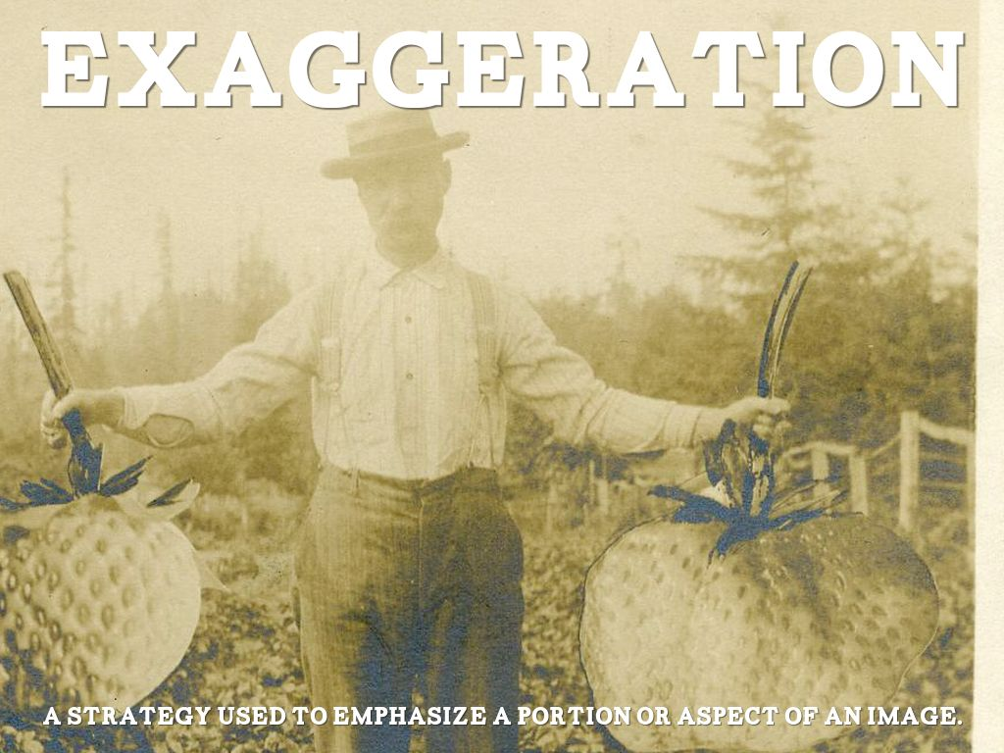
3. Juxtaposition | 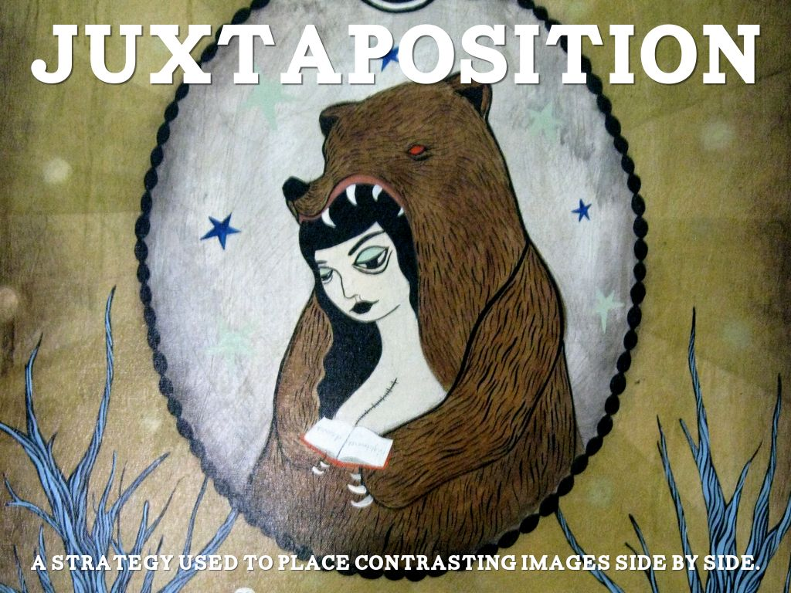
4. Reversal | 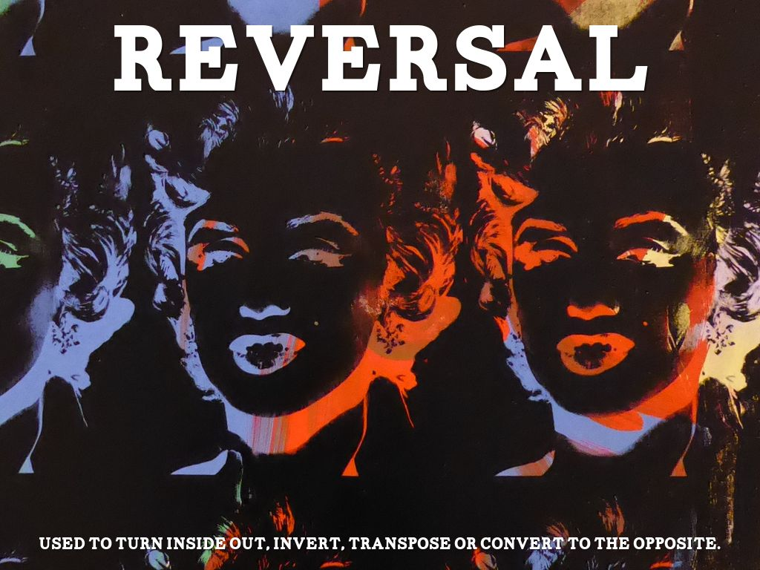
5. Fragmentation | 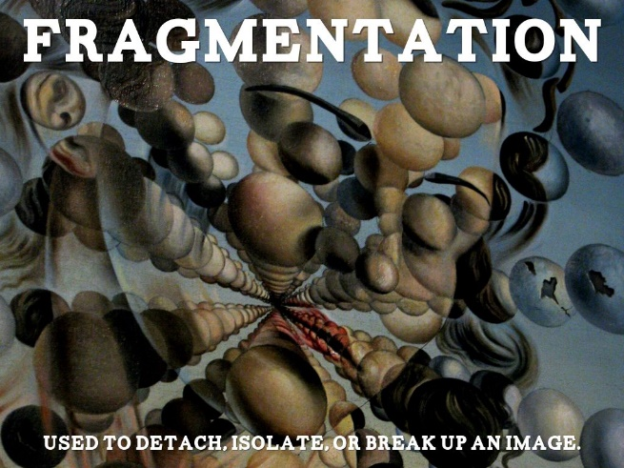

- Before you start:
You must do the following before you start.
- Collect at least 3 images of inspiration that you will use to help sketch out a prototype for you assignment. Images should be saved and put on your blog.
- Create a prototype/hand sketch draft for what your project will look like. Photo must be taken and put on your blog.
2. Creating your project
Please reference the rubric for what I am looking for with regards to skill, use of time, technology, use of theme.
3. Post your project
You project must be posted on your blog in the form or a JPEG or PNG (image file,) along with the following reflection questions:
- What image-development strategy did you choose to base your project on and why?
- You were to choose at least 3 images to use as inspiration. What element or principles of design and image-development strategies did you like and how did you incorporate them in your sketches.
- What was one thing you felt you did well, design wise in your project and one thing you felt you did well, technology wise with this assignment?

