Lab Choice 1- Adjustments

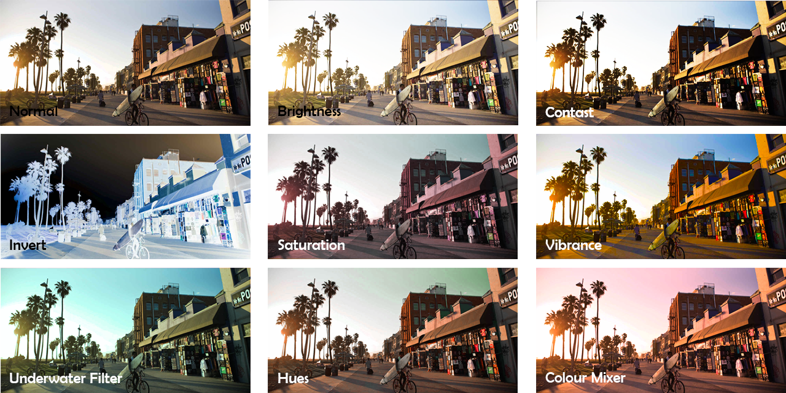

- Open Photoshop
- File> New
- Create a new document that is 900 x 900 pixels (if you don’t change your units to pixels your image will be HUGE)
- Search a photo (medium to large in size please make it a photo not a vector image,) and save it to your hard drive
- Copy and paste your photo into Photoshop (when you paste into Photoshop, select Edit>Paste. You will notice that your photo has been pasted onto a new layer in the bottom right corner)
  - You can also drag and drop your photo from your file in Photoshop. You’ll notice that your photo is pasted into a layer that is labelled background. Unlock that layer.
- Crop and size your image so it can fit 9 times into the file (do not distort your image! Crop it to make it a square)
  - To crop and adjust your image, press clt + t (free transform tool) and hold down shift to maintain the shape of the image.
  - If you need to resize the image, select the move tool, then tick this box just below your main menu . This will put points around your image that you can grab with the move tool 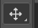 to make larger or smaller. Remember to hold shift to keep the image proportionate
  - To copy your image, select the Rectangular Marquee Tool and draw a square around your image
  - Once your image is selected, hit clt + c to copy and clt + v to paste.
    - You’ll notice that once you hit copy on your keyboard, another layer will appear in your layers panel. You can then start moving your images around.
- Copy and paste your image to give you 9 images.
  - You can also duplicate the layer: click on the layer and drag it over the 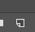 new layer icon at the bottom of the layer menu.
* Each photo should have its own layer
- Move each layer until the images are organized into three rows and three columns
  - If you’re having issues moving the image, you must be on the proper layer, then use your move tool to move the image
- Alter each image (remember you have to be on the correct layer!)
Image>Adjustments
- Choose your adjustments of choice. Be as detailed as you want. You’ll notice that once an adjustment is applied, you will have additional layers.
- Display which adjustment you made on each image with the type tool (same as Illustrator!)
- Save as a JPEG or PNG and post on your blog
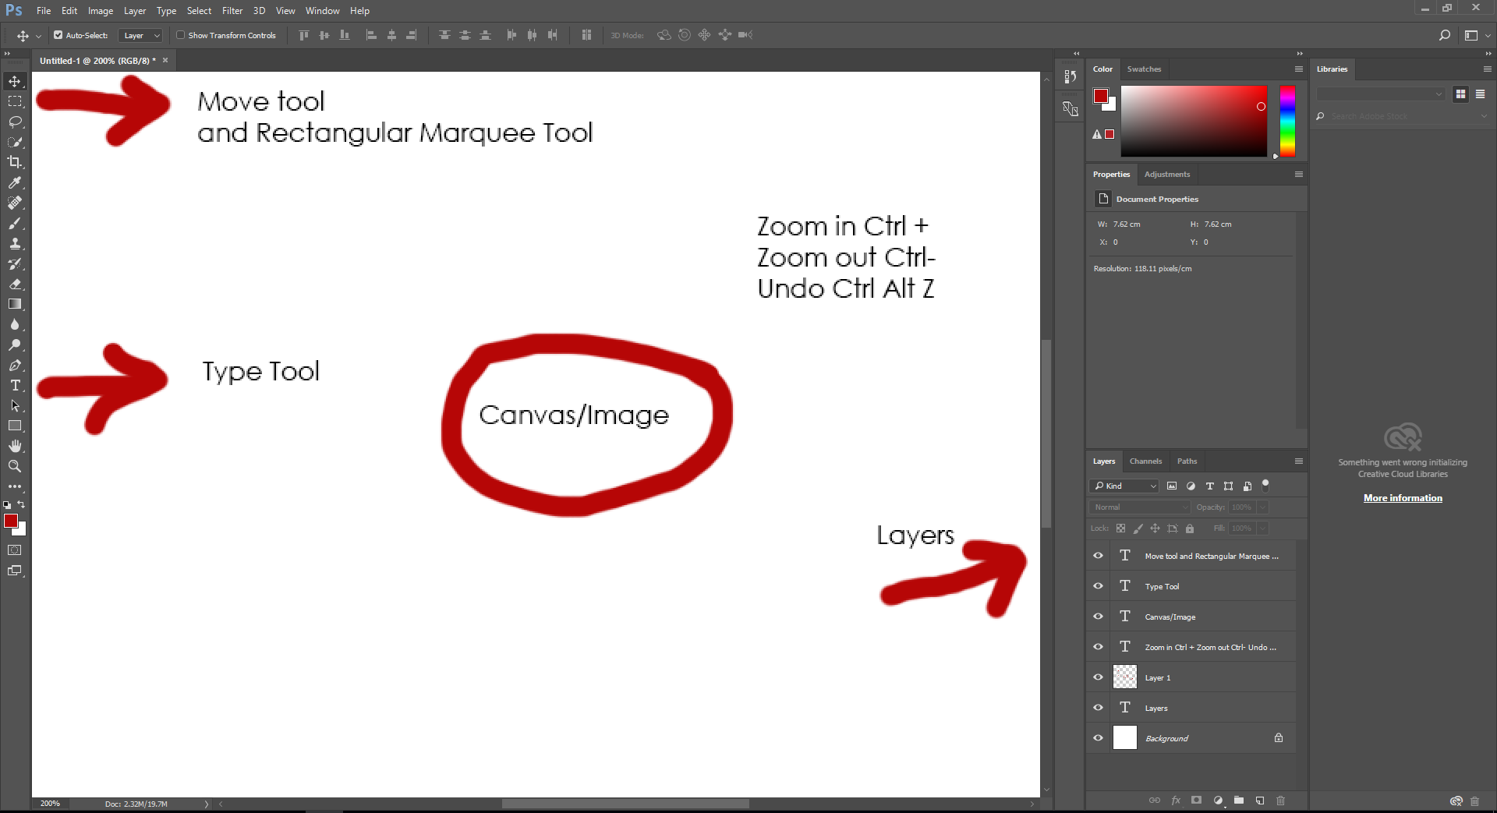
  - **Converting to a png or jpg is NOT the same as Illustrator. Click Save As (instead of export) then change the file type as you did in Illustrator.

