Lab 4- Double Exposure
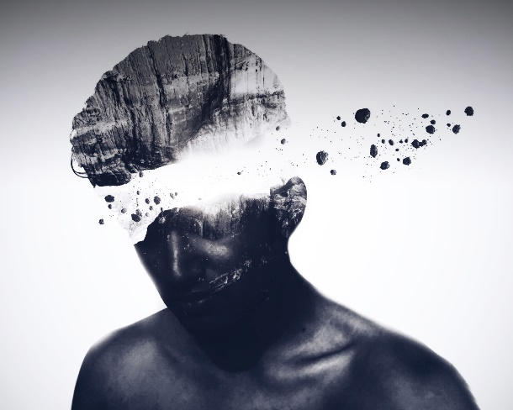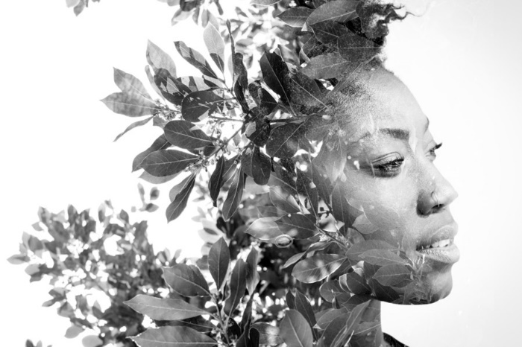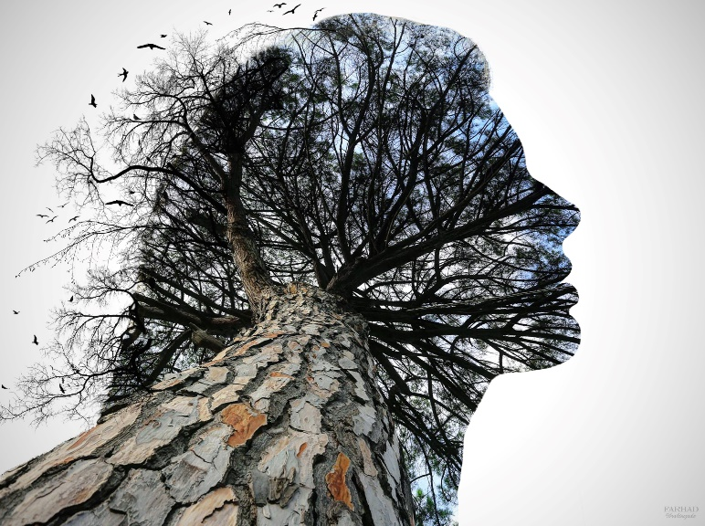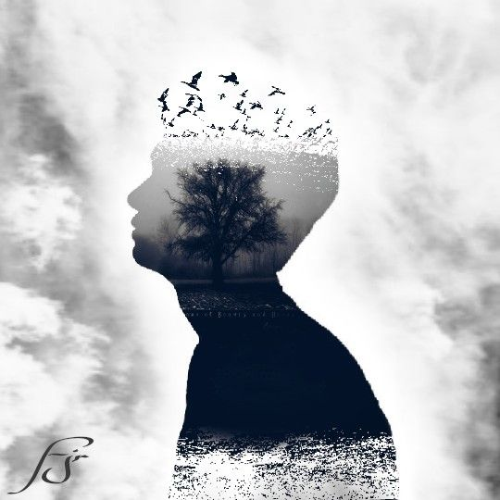
For this double exposure you can either do a portrait or you can use two different images that make sense. To take your portrait, either use a picture of yourself that you already have, OR ask a friend (or Ms. Sihota) to take your picture against a white wall. Email yourself the portrait and save the image to your file.

- With your image opened in Photoshop, Click on the channels tab in your layer menu.
- Choose which color layer has the highest contrast, then duplicate the layer by dragging it over the new layer icon (down at the bottom) hover over the icons to distinguish which one is the “new layer” icon.
- Go to image adjustments > Levels
  - Adjust the dials on this menu to try and make as much contrast as possible
- Using your paint brush tool, paint over any remaining details. Make sure you adjust the hardness of your brush
- In your channels layers select the RBG color layer (all layers should select)
  - Then hold down the ctrl key and then select the duplicate layer you made your adjustments on. Then go to “select > inverse” and the portrait should now be perfectly selected
- Return to the layers tab and click ctrl C then ctrl V to copy and paste the selection of the portrait
- Paint your background layer white (use the paint bucket or a large paint brush. You may also need to unlock the layer in order to paint)
- Copy and paste your second image into photoshop
- Move your layers so that your portrait is below your new image (if need be)
- With your new image layer selected, press ctrl then click on the thumbnail of the portrait 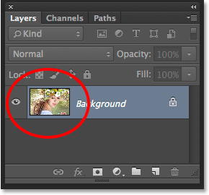
- You should now have your portrait selected
- Apply a layer mask to your new image by clicking on the icon which is next to the new layer icon in your layers menu
- Unlink the mask of the layer (that little chain icon between the icons on the layer) then click on the icon of the new image.
- Duplicate your portrait layer and bring it to the top of your layers
- Click on image (top of the page) adjustments>desaturate (this will make your photo black and white if it isn’t already
- Then click on the drop down menu that says ‘Normal’ above the layers panel and select “multiplty”
- Apply a layer mask to the layer by clicking on the icon
- Select your paint brush tool. Enlarge the size of the brush and make the brush as soft as possible then paint over the details of your portrait except for you face
- Play with your opacity settings to get the look you are hoping for
- Select a color from your second image, lighten the color and paint your background with this color
- Copy and paste your second image into your layers AGAIN and make sure the layer is at the top
- Then go to the filter tab from the top menu and select blur> Gaussian Blur
- Change the pixels in this menu to 250
- Put another clipping mask on this layer, then use your paint brush again to expose your portrait from behind
- If the color is too bold, turn down the opacity setting
The link to the video of this tutorial is below! Please use the instructions and the video to help guide you through the process
Save your image as a jpg or png and post to your blog!
https://www.youtube.com/watch?v=Mbf-QXCCXgM
Key words: contrast

