Lab 2: Face Swap Lasso & Eraser Tool
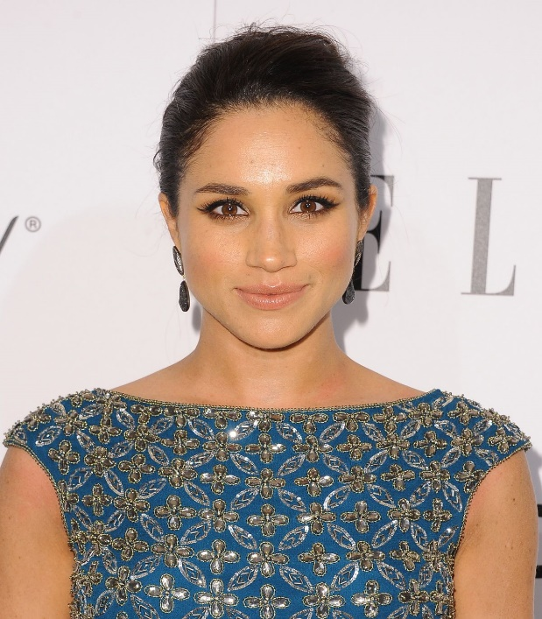
In this lab you will be practicing your lasso tool and/or your magnetic lasso tool while learning how to use the eraser tool to better blend in your colouring.

Pick two images of a celebrity or star of your choice. It is easier to use people who have tones in their skin that are relatively close together. The photos provided above are two images that are a good example of two people who have skin tones that are similar.

Step by Step
- File > New
- Pixels can be set at 900 x 1200
- Import the images that you would like to work with. You may want to rearrange your layers however you want.
- Once you have both images placed into a file. Use your lasso tool to circle/highlight the area you would like to copy and paste onto the other face. Edit > Copy or clt + c
- Edit > Paste or clt + v the image onto the photo in which you would like to change the face.
  - Once you copy and paste the section you selected you’ll notice that you’ll have an additional layer- this is what you want.
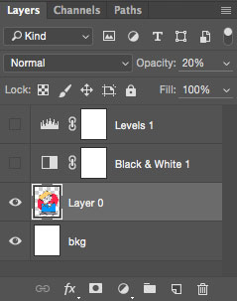
- Edit > Transform OR Edit > Free transform (or clt + t.) This will allow you to change the copied and pasted face to fit the second image.
  - Change your opacity to 50% or lower so you are able to match up the face perfectly. (ie. Eyes match up with eyes)
- Once you have matched up your copied and pasted face, set your transformation to the image by hitting the check mark on the top of your screen or double clicking.
- You will notice that there is a hard line that it quite obvious. Select your eraser tool. You are able to change the side, hardness and opacity of your erase tool which, will help you blend.
GOOD LUCK!

