Lab 2- Filters
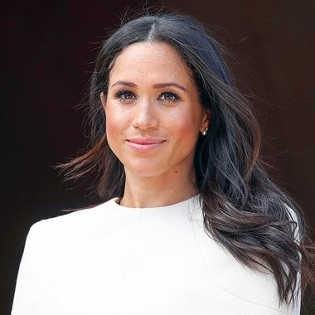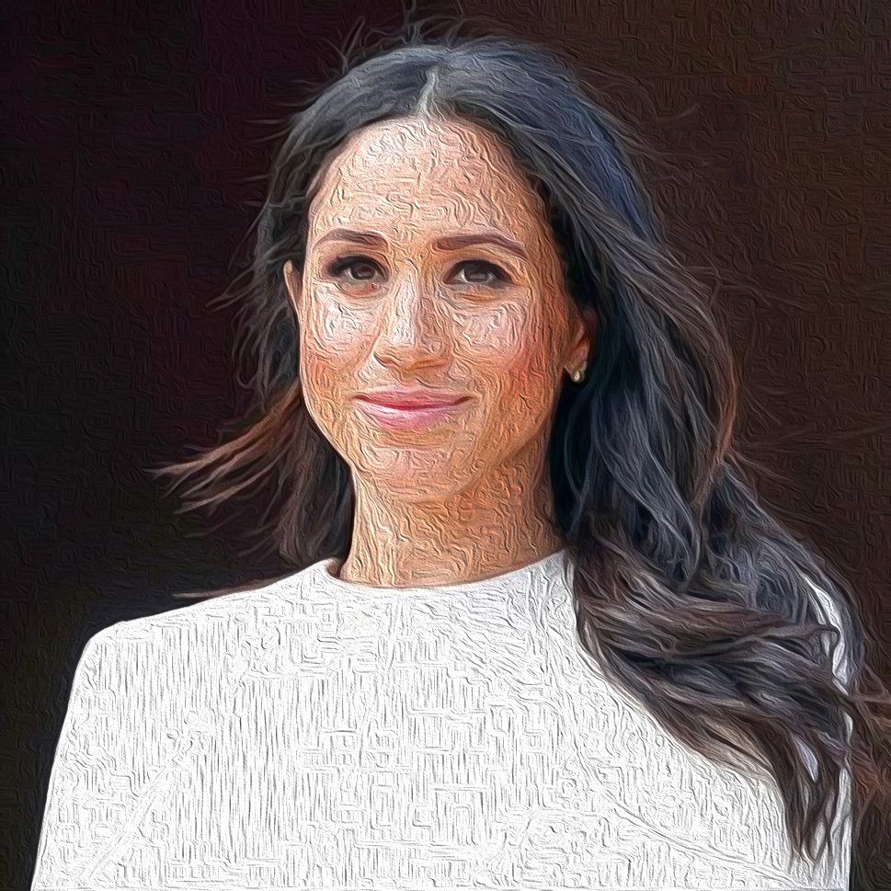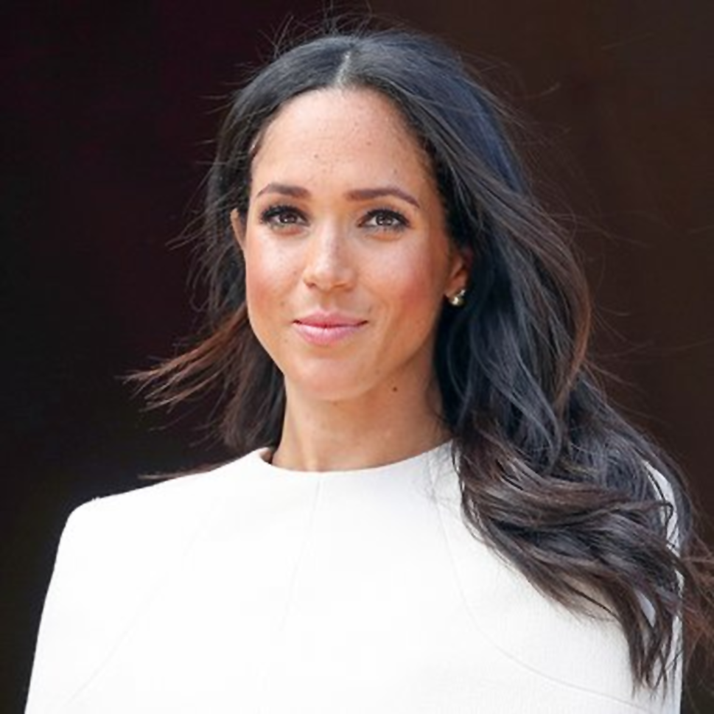

Filters
In this lab, you will find an image, copy and paste it into Photoshop, then manipulate the image using different styles of filters. As you can see above, the picture on the left is the original and the other two were created with filter effects. In this lab you are to use at least 5 different filters and post them all to your blog. These five filters do not need to be on the same image.

Step by step:
- Open Photoshop
- File>New
- Create a document that is a minimum 400 x 400 and maximum 600 x 600 (consider the shape of your image!)
  - You can always crop your image to it’s appropriate size using the crop function. 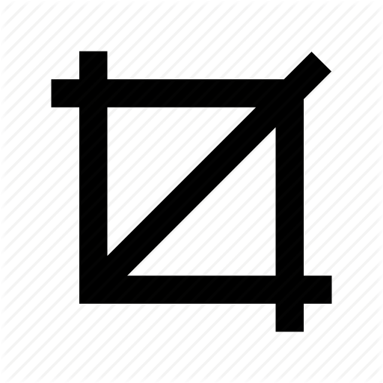
- Copy and paste you image into the document 9 times (3x3 grid)
- Main tools you will be using are:
  - Filter> Liquify
  - Filter> Filter Gallery
- Don’t forget to label the images with the filter used
- You will notice that you are using image development strategies! Such as distorting, simplification, animation, etc
- When you finish, save the image as aJPEG or PNG and add it to your blog

