3D Photoshop Lab 1
In this lab you are to create 5 different images that cast different shadows on your 3D object. These 5 images must be complied into all one document. You are to think critically and creatively on the different ways that you could do this using any of the applications that you have learned up to date. The best way to do this is by exporting your images as a JPEG or a PNG.
When you are creating your 3D images- make sure that you are in 3D work space. You’ll find this option up in the top right hand corner. 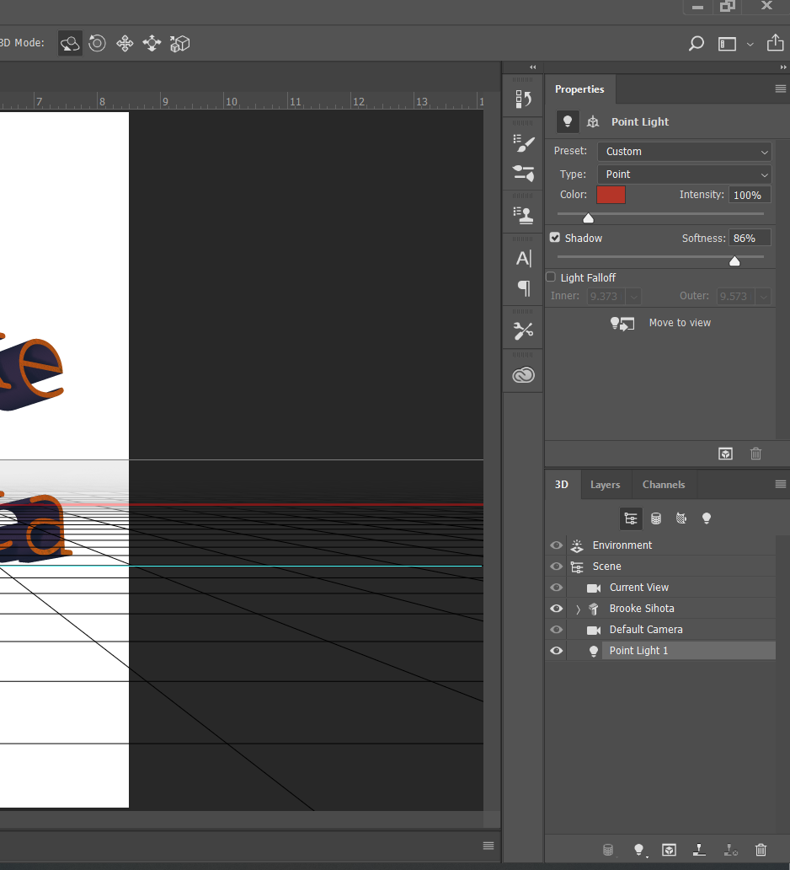
You’ll notice that on the right hand side that your menu options have changed from the basic menu. Toggle back and forth between the essential screen and the 3D work space to notice the difference.

First: Once you have added in your text to you must go to the top where it says 3D. Once you have done that go to the item on the drop down menu listed as new excretion from selected layer. This will help fill in your properties panel.
REMINDER: Your 3D functions up on the top either help you navigate through your general current view settings or your object.

