Vocabulary
ACTIVITY GUIDE- INPUTS & OUTPUTS
- Input: A device or component that allows information to be given to a computer
- Output: Any device or component that receives information from a computer

Inputs and Outputs
For each category of computer brainstorm as many inputs and outputs as you can.

Computer | Inputs | Outputs
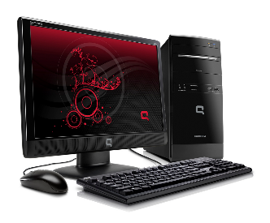
Desktop
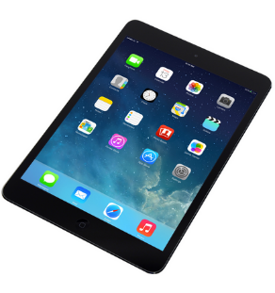

Table
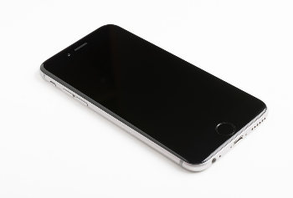

Smartphone

Digital Assistant

Fitness Tracker
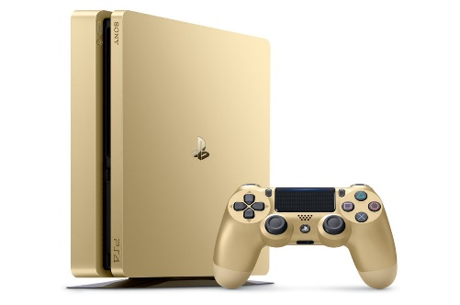

Game System

