Sorting Activity- Computer Processing

Objective
Develop steps to sort a row of cards, using the rules below

Tips
- Start with only 3 or 4 cards and work up to 8.
- Switch roles frequently.
- Practice with the cards face up first
- Test your work and even try to “break” your solution.
Stick with it! There are many possible solutions. The point is to find yours!
.
Rules
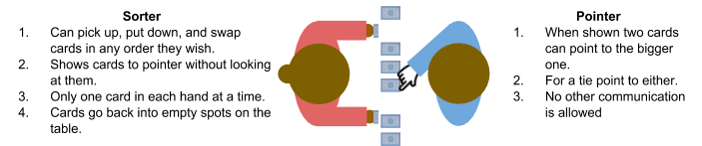

Your Steps
Once you’ve developed your steps for processing cards, write the steps of your way of processing the cards in the space below. Feel free to draw pictures, number steps, or do anything else you think would be helpful.

Share and Test
Present your steps to another group. Make sure both groups get a chance to share and test their ideas. Here’s some tests to consider.
- Use different numbers of cards
- Cards are in reverse order
- Cards are already in order
- Cards are nearly in order

Iterate
Based on your tests or ideas from another group, update your steps.

Processing Uses Algorithms
Processing is anything a computer does to turn input information into output information. Humans can process information, but usually they’re making lots of assumptions or mental leaps to do it. When computers process information, they use algorithms, or sets of instructions, that will always turn an input into a desired output. The steps you just created are an algorithm to sort cards.

Reflection
1. What step of the problem-solving process did you think was most important in this activity? Why?
2. Why would someone create an algorithm to process information if they already know how they would do it by hand?

