Journal & Activity 4- App Exploration

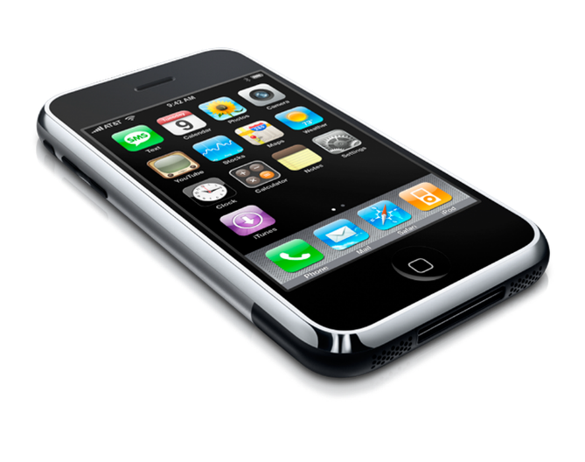
In this activity, you’ll decide how a computer (in this case, a smartphone) can use different types of information to solve a problem. You’ll need to figure out which inputs the computer should use to get the necessary information, and whether or not the information should be stored for later.

Next, you’ll decide how the information should be processed, using sorting, matching, or counting, and use that method to find what the computer should output. Once you’ve figured out how the app should work, you’ll have a chance to think of some improvements.

ACTIVITY

Ring Silencer App: This app solves the problem of the user’s phone ringing in class. It figures out when the phone is at a school and turns off the ringer. It turns the ringer back on when the user leaves school.

- What type of output should the app produce? ________________________________________________________

Prepare
- Fill out the following table with information that the app needs and whether you will find the information from a phone sensor or the Internet. Decide whether you want to store the information for later.
Information | Where will you find the information? | Store for later?

- Choose the type of processing you will use, and explain how it will help you get your output.

Sorting / Matching / Counting

Try: Use the method you created above to process the information.

- What is the output? .

Reflect: This app turns off the ringer even when the user is not in class. An advanced version would only turn off the ringer at school when the user is quiet and not moving. If the user is moving around or making a lot of noise, it would assume that it is not class time and keep the ringer on.

- How would you change your app to solve this new problem?

- Where would it find the new information that it needed?

Journal & Activity 4- App I/O

ACTIVITY

Movie Recommendation Challenge

Define: This app addresses the problem of not knowing what movies to watch. Look through the information available to you, and decide what will help to choose a movie for the user.

- What type of output should the app produce? _________________________________________________________

Prepare: Fill out the following table with information that the app needs and whether you will find the information from a phone sensor, the Internet, or user input. Decide whether you want to store the information for later.

Information | Where will you find the information? | Store for later?

- Choose the type(s) of processing you will use, and explain how it will help you get your output.

Sorting / Matching / Counting

Try: Use the method you created above to process the information.

- What is the output? __________________________________________________________________________

Reflect: Compare your method, and the inputs it needed, to another group’s method.

- What is one advantage of the other group’s method?

- How might you combine your ideas to make a better app?

