Illustrator Assignment 1- Using the Pen Tool
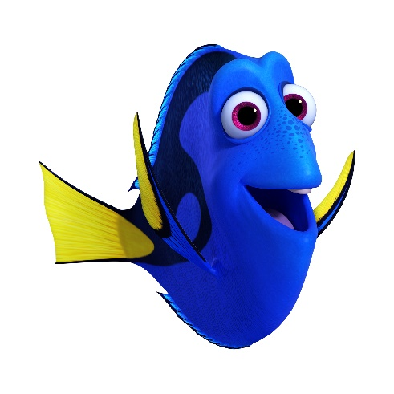

Assignment 1:

For this assignment, you will follow the tutorial from the link below to create a cactus character. When you complete the cartoon, go to File> Export and save the cactus to your folder as a png file. Name the file lastnamefirstname_assignmen1.

https://www.youtube.com/watch?v=oYv9_hWEx5k
https://www.youtube.com/watch?v=j69a3-shkGE
https://www.youtube.com/watch?v=b9OTyAel3D8

Please reference the next page for the step by step guide if you get lost.

TRACING A SUPERHERO

In this first tutorial, you
- Find an image of your favorite superhero. Make sure you find an image that is medium to large in size and shows the entire body of the character.
- Create a new document in Illustrator (Click File>New and create a document that is 8.5 x 11 inches – standard US paper)
- Right click to copy the image from google then go back to Illustrator. From there, click Edit > Paste
- Adjust the size of the image to your liking using the black arrow tool.
- Open your layers window (Window>Layers), create a new layer on top of the image layer(exactly how you would in Photoshop).
- Lock the image layer by clicking the empty box next to it.
- Now you can draw over the image without it moving around.
- Using the brush tool, trace the image
- When every line is traced, select everything with the Arrow tool.
- Click >Object>Live Paint>Make. This will combine all of the lines you have made so you can simply use the paint bucket tool to color. **If there are parts of your character that you cannot color, then you have not properly connected your lines. Use the brush tool again to fill in any gaps between lines. Combine the lines again and then try coloring.

