Lab 2- Clone Tool

- File > New
- Pixels can be set at 900 x 1200
- Pick a photo that you want to have something removed. The objective of using a clone tool is to use it to remove an object that you do not want in the photo
- Once you have pasted your photo into Photoshop you’ll see that there is a layer dedicated to that photo.
- Create a new blank layer. This layer should be on top of your current layer.
- Select the clone stamp tool that looks like 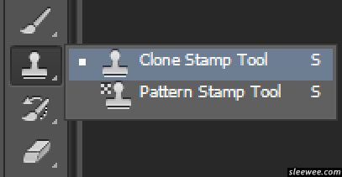
- Once you have selected your clone stamp tool, make sure that you have allowed Photoshop to select colour samples from all layers.
- Changing your sample selection will allow you to sample colours from all of the layers that you create and that appear in your panel.
- To select a sample colour hold down alt and click anywhere on your screen.
- If you move your mouse/hover your mouse in another area, you’ll notice that your previous sample colour should appear.
10. If you left click, you’ll see that the colour was cloned to another spot on your screen.
You can use this tool to erase blemishes on a photo, remove objects completed or clone/double an object.

